Thursday 2nd April Literacy
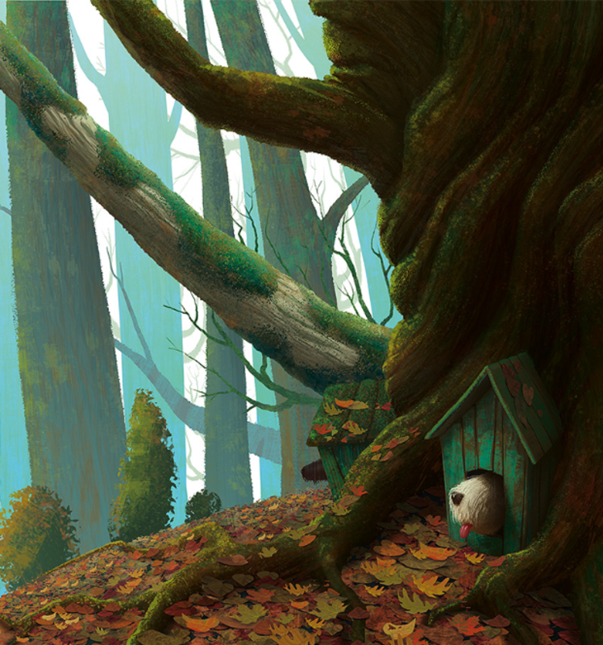

Perfect picture!
Can you draw a picture of the perfect house for a dog to live in? Draw and label the inside as well as the outside. Think carefully about what it might have inside it.

Maths:
Complete White Rose Maths – Lesson 4 – Tenths on a number line.

Please log in to TT Rockstars and Sumdog and play each for 15 minutes.
Don’t forget to try and complete the challenges!!

