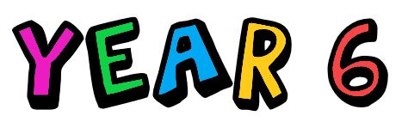
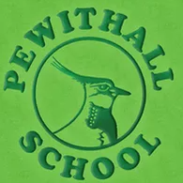

Pewithall Primary School

Curriculum booklet 2021-2022

This year, your child will be in Year 6. This year is an exciting and special year. Not only will they be coming to the end of their learning in KS2, but they will also begin to get ready for their transition to secondary school. Your child will also complete their SATs. In order to be successful in Year 6, your child needs to be ready to: smile, laugh, learn, ask for help, be independent, be their best and make every Pewit moment count- this year goes very quick!

This year your child will study:

Writing/SPaG


From September 2021, Year 6 will be taught English using a scheme called Pathways to write.

Pathways is a brand-new methodology designed to equip pupils with key skills to move them through the writing process towards their final outcome. It is built around units of work that follow a mastery approach to the teaching of writing.

To support this approach, clear detailed lesson plans and resources are linked to a high-quality text. Pathways to Write ensures engaging and purposeful English lessons. The units can be used thematically to encourage a whole school approach to writing with the opportunity for topics to link across all year groups.

Each unit covers a range of areas in the national curriculum:

Mastery of vocabulary, grammar and punctuation skills
Writing a range of genres across a year
Vocabulary development
Using a wider range of reading comprehension strategies as a whole class
Spoken language activities including drama and presentations
Opportunities for practising previously taught genres
An extended, independent piece of writing.
Your child will read the following books below. The text in blue will be our class novel and it would be beneficial if your child had their own copy of this text.

Autumn 1 | Autumn 2 | Spring 1 | Spring 2 | Summer 1 | Summer 2
Star of Hope, Star of Fear by Jo Hestlandt  An Eagle in the snow by Michael Morpurgo | Can we save the tiger? By Martin Jenkins  Jungle Book by Rudyard Kipling | Selfish Giant by Oscar Wilde  Gulliver’s Travels retold by Martin Jenkins | Jemmy Button by Alix Barzelay  The Island by Jason Chin  The Explorer by Katherine Rundell | Manfish by Jennifer Berne  Dolphin Song by Lauren St John | Skychasers by Emma Carroll

Reading
In Year 6, we do guided reading every day. The children will already be familiar completing VIPERS in Year 5. The children will be given a new age-related text in class, each week.
Firstly, they will generate questions and predictions about their text and the following session the children will read this text with their reading group and an adult to support and discuss the themes, language features and plot of the text. Following this session, the children will complete their VIPER sheet where their comprehension skills will be needed and the understanding of the text.
The children will also complete a short SATs style question. This will be based on another text and will make the children familiar with the reading booklet layout and the amount of text, which they will need to be able to read, understand and apply to the question given.
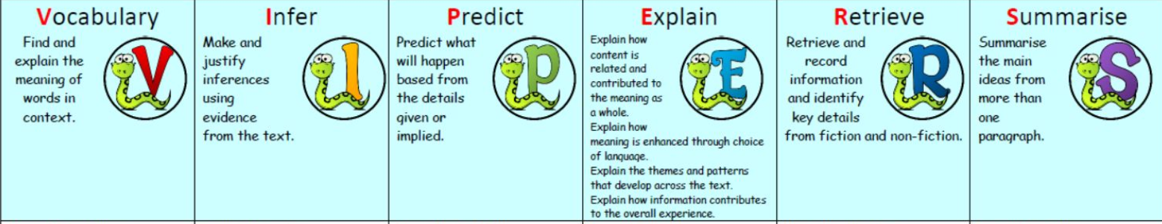

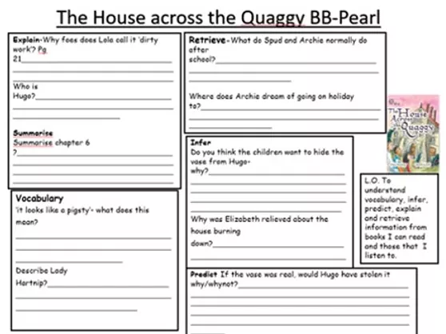
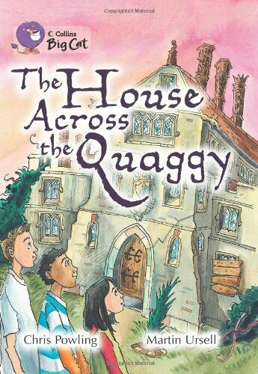

What can you do to help?

Please ensure that you read with your child regularly. Sign their diary and encourage them to read books of their interests. Even reading football match reports in the newspaper can support their reading and confidence as well as their love for reading. Support them when reading different genres of texts- magazines, newspapers, novels, diaries etc.
The children will read longer texts this year. It is vital that they read regularly so they are fluent and have the stamina to read for longer periods of time.
Spelling tests will be on Wednesdays. The children will be given their new spellings on this day. If your child loses their spellings, they are always available in the pot in our reading area. Please encourage them to take responsibility for organising themselves and practising at home.

Maths

Year 6 use Power Maths as our Maths scheme. The children will be familiar with the scheme and objectives from Year 5. Many of the objectives in Year 6 are first visited in Year 5, so the children will be familiar with certain topic areas and in some cases will just be consolidating their knowledge. It is also important to note, due to the pandemic, some lessons will revisit Year 5 content so all children can access the Year 6 content. Some topics areas have not been covered from Year 5 due to the pandemic and will be covered alongside Year 6 content.

Below is the year overview of the topics, that your child will be taught.

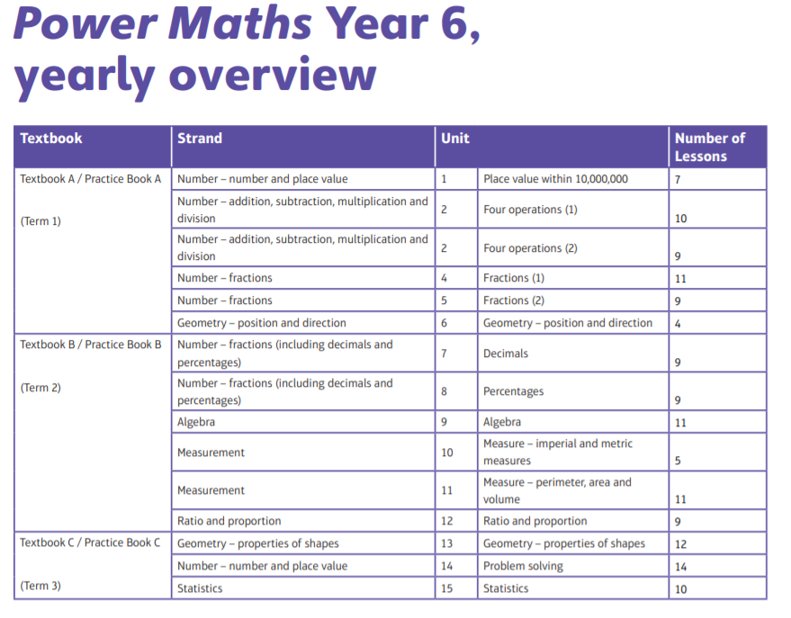

This year your child will be learning and consolidating the following knowledge and skills:
- They will extend their understanding of the number system and place value to include larger integers and this will develop the connections that they make between multiplication and division with fractions, decimals, percentages and ratio.
- The children will develop their ability to solve a wider range of problems, including increasingly complex properties of numbers and arithmetic, and problems demanding efficient written and mental methods of calculation.
- With this foundation in arithmetic, the children will be introduced to the language of algebra as a means for solving a variety of problems.
- In geometry and measures, the children will consolidate and extend the knowledge that they have developed in number.
- The children will learn to classify shapes with increasingly complex geometric properties, and they will learn the vocabulary they need to describe them.
- Throughout Year 6, the children will develop fluency in written methods for all four operations, including long multiplication and division, and in working with fractions, decimals, and percentages.

What can you do to help?
Please ensure that your child knows all their times tables and related division facts. Please also help your child to practise creating derived facts from times tables: 3 x 6 = 18, so 30 x 6 is 180, or 42 ÷ 0.7 = 60. Another extremely useful thing for them to know is how to convert between decimals, percentages, and fractions. For example, that ½ is the same as 50% which is the same as 0.5 etc.
Encourage the children to use the apps- Sumdog and TT Rockstars.

Science

Science is taught on Mondays by Mrs McGarry.
In Science, Year 6 will study the following topics:
- Animals Including Humans
- Light
- Evolution and Inheritance
- Electricity
- Living Things and their Habitats

What can you do to help?
Please use our class page on the school website to access the knowledge organisers.




Learning Projects

Learning project is the umbrella term for geography, history, art and design, design and technology, and music. The topics this year will also link to the texts which your child will use in English. These subjects will be taught through the following themes:
- The Holocaust- History focus
- South America- Geography focus
- ABBA- Music and art focus

What can you do to help?
Please use our class page on the school website to access the knowledge organisers.

In Art and Design, the children will learn and practise the following objectives:
- They will create sketch books to record their observations and use them to review and revisit ideas
- They will improve their mastery of art and design techniques, including drawing, painting, and sculpture with a range of materials [for example, pencil, charcoal, paint, clay]
- They will learn about great artists, architects, and designers in history.

In Design and Technology, through a variety of creative and practical activities, the children will be taught the knowledge, understanding and skills needed to engage in an iterative process of designing and making. They will work in a range of relevant contexts [for example, the home, school, leisure, culture, enterprise, industry and the wider environment] and within the context of the overarching curriculum themes.
In Geography, the children will extend their knowledge and understanding beyond the local area to include the United Kingdom and Europe, North and South America. This will include the location and characteristics of a range of the world’s most significant human and physical features. They will develop their use of geographical knowledge, understanding and skills to enhance their locational and place knowledge.
In History, the children will continue to develop a chronologically secure knowledge and understanding of British, local and world history, establishing clear narratives within and across the periods they study. They will note connections, contrasts and trends over time and develop the appropriate use of historical terms. They will regularly address and sometimes devise historically valid questions about change, cause, similarity and difference, and significance. They will construct informed responses that involve thoughtful selection and organisation of relevant historical information. They will understand how our knowledge of the past is constructed from a range of sources.
In Music, the children will be taught to sing and play musically with increasing confidence and control. They will develop an understanding of musical composition, organising and manipulating ideas within musical structures and reproducing sounds from aural memory.



PE

Children will be taught to:
- use running, jumping, throwing and catching in isolation and in combination
- play competitive games, modified where appropriate [for example, badminton, basketball, cricket, football, hockey, netball, rounders and tennis], and apply basic principles suitable for attacking and defending
- develop flexibility, strength, technique, control and balance [for example, through athletics and gymnastics]
- perform dances using a range of movement patterns
- take part in outdoor and adventurous activity challenges both individually and within a team
- compare their performances with previous ones and demonstrate improvement to achieve their personal best.


P.E teaching will be taught by Multiflex on Monday. Miss Webster will teach PE on Friday mornings.

Religious Education

In Religious Education, the children will use developing religious vocabulary to describe and show understanding of religious traditions, including sources, practices, beliefs, ideas, feelings and experiences. They will also compare different viewpoints within a faith group. They will explain what inspires and influences them, expressing their own views whilst respecting other people. They will ask important questions about religion and beliefs. They will analyse religious information and begin to develop their own opinions.
The religions covered will be: Christianity, Sikhism and Buddhism.


Computing
In Year 6, the children will learn to:
- design, write and debug programs that accomplish specific goals, including controlling or simulating physical systems; solve problems by decomposing them into smaller parts
- use sequence, selection, and repetition in programs; work with variables and various forms of input and output
- use logical reasoning to explain how some simple algorithms work and to detect and correct errors in algorithms and programs
- understand computer networks including the internet; how they can provide multiple services, such as the world wide web; and the opportunities they offer for communication and collaboration
- use search technologies effectively, appreciate how results are selected and ranked, and be discerning in evaluating digital content
- select, use and combine a variety of software (including internet services) on a range of digital devices to design and create a range of programs, systems and content that accomplish given goals, including collecting, analysing, evaluating and presenting data and information
- use technology safely, respectfully and responsibly; recognise acceptable/unacceptable behaviour; identify a range of ways to report concerns about content and contact.

What can you do to help?


If you have a computer, encourage your child to practise skills learnt at school and access tasks on Microsoft Teams.

French

French will be taught once a week by Miss Webster. There is an emphasis on speaking and communciation so the children are able to progress to secondary school with confidence and basic french vocabulary and grammar knowledge.

Our topics are:
The children will be taught to: Everyday life, where I live, where you live, Playing and enjoying sport, This is me, hobbies and fun, Cafe culture and restaurants and Tour de France.
,

- listen attentively to spoken language and show understanding by joining in and responding

- explore the patterns and sounds of language through songs and rhymes and link the spelling, sound and meaning of words

- engage in conversations; ask and answer questions; express opinions and respond to those of others; seek clarification and help

- speak in sentences, using familiar vocabulary, phrases and basic language structures

- read carefully and show understanding of words, phrases and simple writing

- appreciate stories, songs, poems and rhymes in the language

- broaden their vocabulary and develop their ability to understand new words that are introduced into familiar written material, including through using a dictionary

- write phrases from memory, and adapt these to create new sentences, to express ideas clearly

- describe people, places, things and actions orally

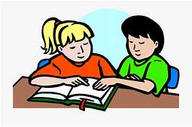
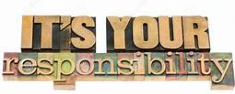
Homework

Homework will be sent home on a Thursday. Your child will have until the following Wednesday to complete this and send it back to school (6 evenings to complete). I cannot stress enough that your child’s homework should be their responsibility. I completely support you helping them, if they are struggling or giving them a gentle reminder to complete it, but it is important they are responsible and are preparing themselves for secondary school, where organisation is key and getting tasks completed will be a basic expectation.
We offer a homework club once a week at lunch time for children to complete their homework in school rather than home. It is not to be used as a social club but a place where children can get support if they need it. I would strongly advise your child attempting their homework at home first, if they have struggled on a question/concept, they are more than welcome to attend homework club. It is important they try their best first.
Late homework or failing to hand it in will result in your child doing their homework at lunch time and break- again in secondary school, this would be a detention.
The children will also receive weekly spelling lists for a spelling test on Wednesday. Please spend time working with your child on learning their spellings, but please also ensure that they understand what every word means and can use it in context.
Reading diaries will be checked daily, if not every other day. Please sign and date that your child has read their book. It is your child’s responsibility to swap their book once their diary has been signed. Again, these books are available in our reading area in our home reading basket.

