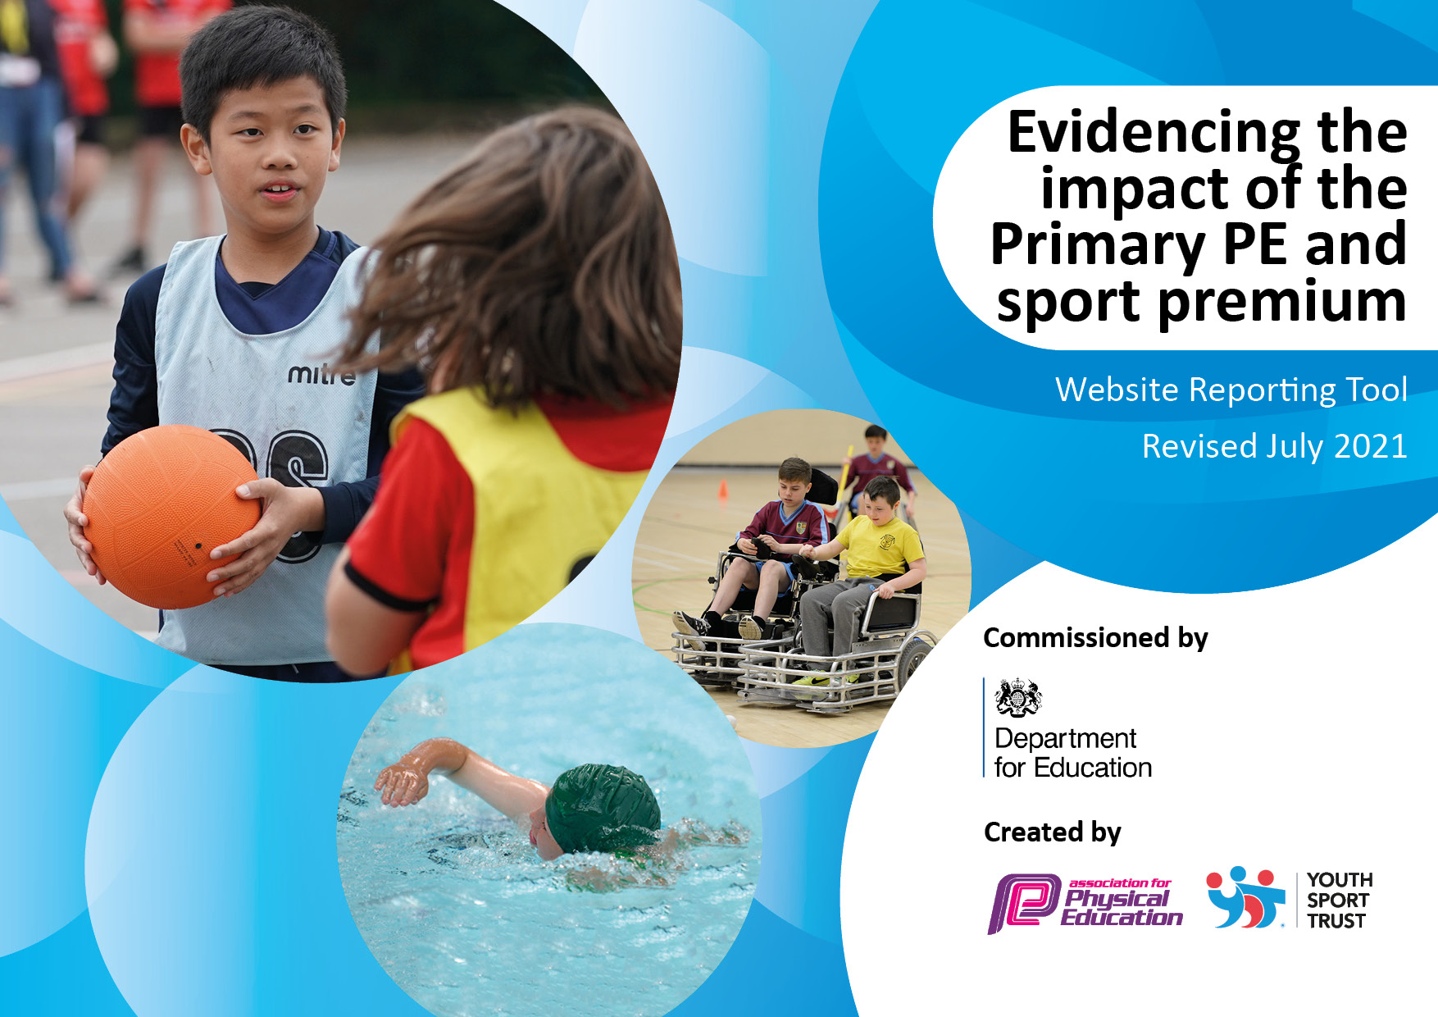
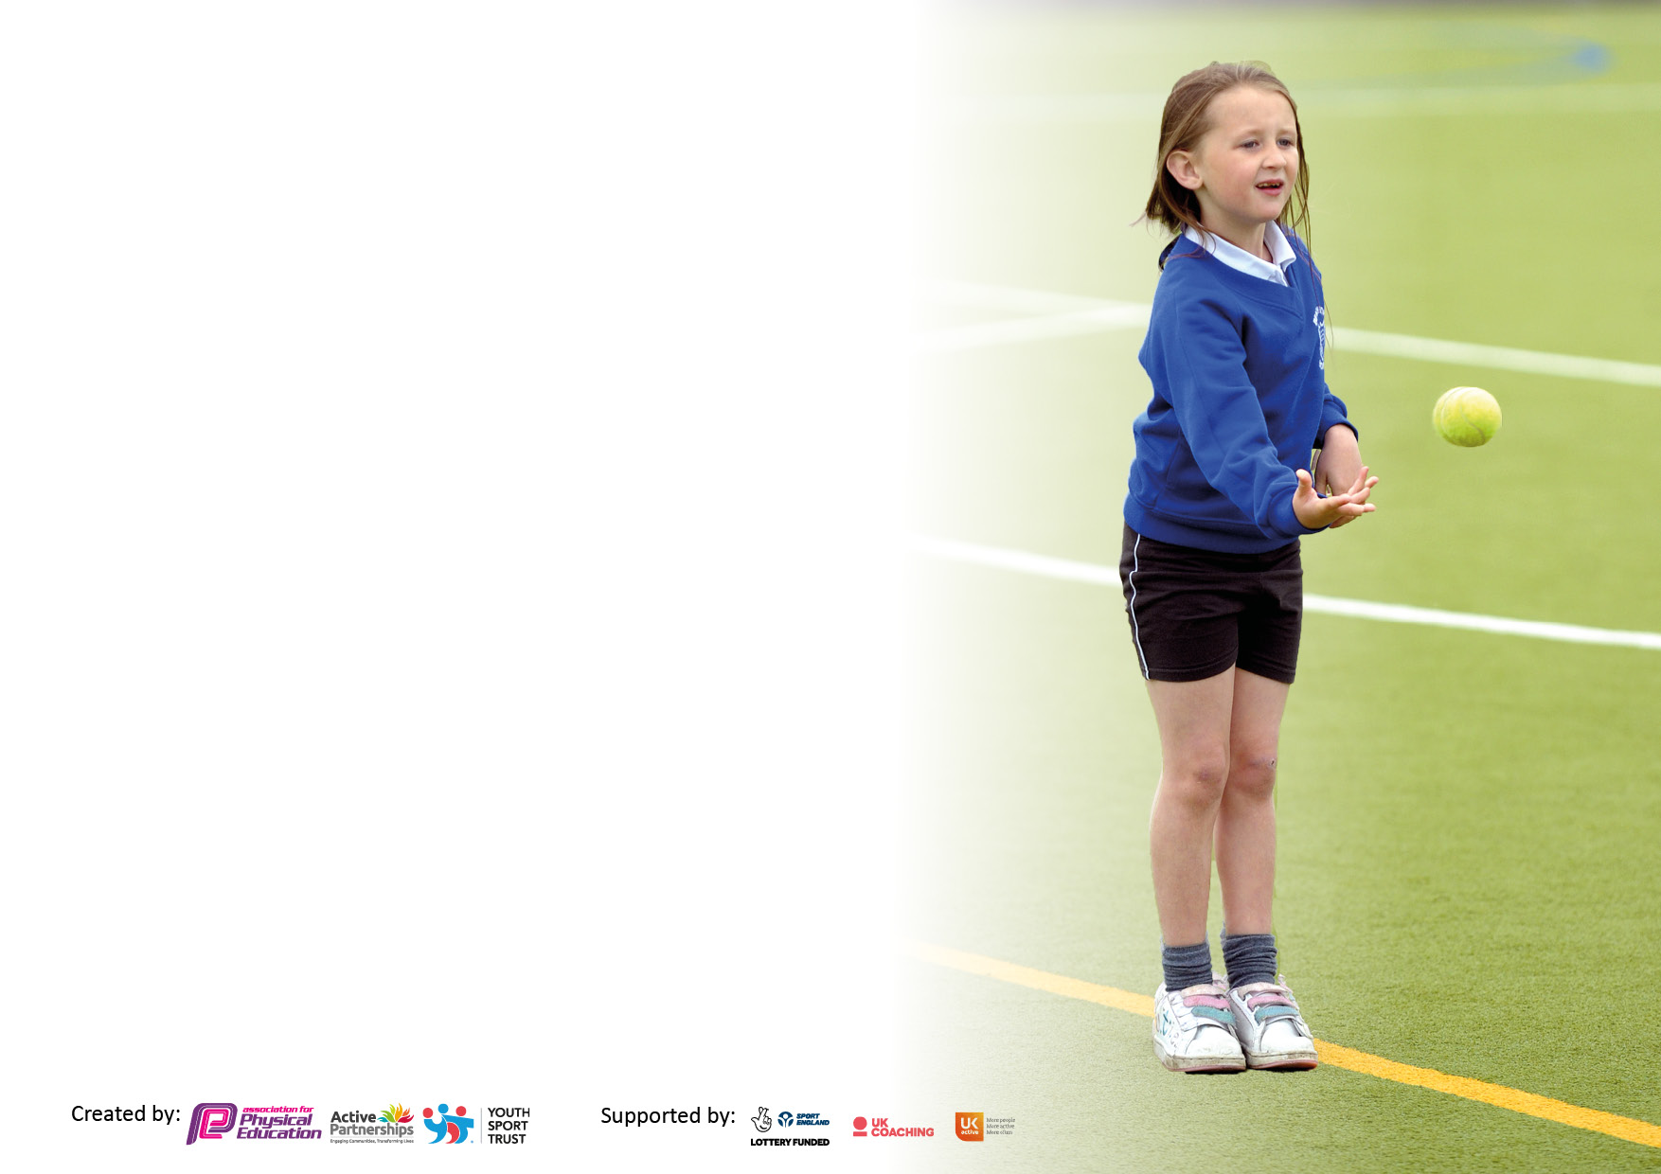

It is important that your grant is used effectively and based on school need. The Education Inspection Framework makes clear there will be a focus on ‘whether leaders and those responsible for governors all understand their respective roles and perform these in a way that enhances the effectiveness of the school’.

Under the Quality of Education Ofsted inspectors consider:
Intent - Curriculum design, coverage and appropriateness
Implementation - Curriculum delivery, Teaching (pedagogy) and Assessment
Impact - Attainment and progress

To assist schools with common transferable language this template has been developed to utilise the same three headings which should make your plans easily transferable between working documents.

Schools must use the funding to make additional and sustainable improvements to the quality of Physical Education, School Sport and Physical Activity (PESSPA) they offer. This means that you should use the Primary PE and sport premium to:

- Develop or add to the PESSPA activities that your school already offer
- Build capacity and capability within the school to ensure that improvements made now will benefit pupils joining the school in future years
- The Primary PE and sport premium should not be used to fund capital spend projects; the school’s budget should fund these.

Pleasevisitgov.ukfortherevisedDfEguidanceincludingthe5keyindicatorsacrosswhichschoolsshoulddemonstrate animprovement.Thisdocumentwillhelpyoutoreviewyourprovisionandtoreportyourspend.DfEencouragesschools to use this template as an effective way of meeting the reporting requirements of the Primary PE and sport premium.

We recommend you start by reflecting on the impact of current provision and reviewing the previous spend.

Schools are required to publish details of how they spend this funding, including any under-spend from 2019/2020, as well as on the impact it has on pupils’ PE and sport participation and attainment. All funding must be spent by 31st July 2022.

We recommend regularly updating the table and publishing it on your website throughout the year. This evidences your ongoing self-evaluation of how you are using the funding to secure maximum, sustainable impact. Final copy must be posted on your website by the end of the academic year and no later than the 31st July 2021. To see an example of how to complete the table please click HERE.
Created by: Supported by:

Details with regard to funding
Please complete the table below.

Total amount carried over from 2019/20 | £0
Total amount allocated for 2020/21 | £17,883
How much (if any) do you intend to carry over from this total fund into 2021/22? | £6300
Total amount allocated for 2021/22 | £17,883
Total amount of funding for 2021/22. To be spent and reported on by 31st July 2022. | £24, 883
Swimming Data
Please report on your Swimming Data below.

Meeting national curriculum requirements for swimming and water safety.  N.B. Complete this section to your best ability. For example you might have practised safe self-rescue techniques on dry land which you can then transfer to the pool when school swimming restarts.  Due to exceptional circumstances priority should be given to ensuring that pupils can perform safe self rescue even if they do not fully meet the first two requirements of the NC programme of study | Due to COVID 19 and availability of local swimming pools during the summer term swimming lessons didn’t take place this year.
What percentage of your current Year 6 cohort swim competently, confidently and proficiently over a distance of at least 25 metres?  N.B. Even though your pupils may swim in another year please report on their attainment on leaving primary school at the end of the summer term 2020.  Please see note above | 100 %
What percentage of your current Year 6 cohort use a range of strokes effectively [for example, front crawl, backstroke and breaststroke]?  Please see note above | 75%
What percentage of your current Year 6 cohort perform safe self-rescue in different water-based situations? | 100%
Schools can choose to use the Primary PE and sport premium to provide additional provision for swimming but this must be for activity over and above the national curriculum requirements. Have you used it in this way? | Yes/No

Action Plan and Budget Tracking
Capture your intended annual spend against the 5 key indicators. Clarify the success criteria and evidence of impact that you intend to measure to evaluate for pupils today and for the future.

Academic Year: 2020/21 | Total fund allocated: | Date Updated:
Key indicator 1: The engagement of all pupils in regular physical activity – Chief Medical Officers guidelines recommend that primary school pupils undertake at least 30 minutes of physical activity a day in school |  |  |  | Percentage of total allocation:
 |  |  |  | 13.11%
Intent | Implementation |  | Impact
Your school focus should be clear what you want the pupils to know and be able to do and about  what they need to learn and to  consolidate through practice: | Make sure your actions to achieve are linked to your intentions: | Funding allocated: | Evidence of impact: what do pupils now know and what can they now do? What has changed?: | Sustainability and suggested next steps:
Continue to deliver high quality teaching and learning opportunities for each pupil on a weekly basis. | Introduce a range of alternative sporting opportunities for each year group e.g. Judo and other martial arts, yoga, fencing and military skills. | £ 750 Fencing | Children benefited from extra dance and fencing lessons (pupil voice). | Children to continue to experience a broad range of sporting activities.
Sports Captains’ programme is introduced to promote active play. Y6 sports captains helped to develop sporting skills across the school. | Y6 Sports Captains develop leadership skills in sports.  Children help run and organise a Euro competition in Y6 and Y5. | £ 100  Photocopying resources. | Play Leaders & Sports Captains’ organise and promote activities to encourage children to be active at playtime. | Markings are COIVD-19 compliant.
Pupils will be guided to use the playground markings and equipment during break and lunchtimes to ensure that they are active. | Pupils will be active for at least 30 minutes during each school day (no including PE lessons) | £ 995 | Children have benefited from extra resources out on the playground and are now more active. | Next year to set up a sports council and to train midday assistants in different games.
Restock equipment levels to enable us to perform safe sessions. The playtime equipment will be provided for pupils to develop lessons outside of the P.E. sessions. | New equipment ordered to make sure that lessons adhere to government guidelines. Pupils use equipment effectively outside the P.E. sessions to ensure they are developing additional P.E. skills. | £500 | Pupil and staff voice will indicate that playtimes are active and enjoyable with fewer incidents and accidents.  Lessons are able to be taught keeping children and staff without losing the impact of lessons on learning. | The equipment has encouraged the children to be more active at lunch and playtimes and helped them to develop fairness and leadership skills. A further pupil voice has been conducted and the children feel that playtimes have much improved since the equipment, they reported they enjoy playtime more and feel that they are getting more exercise. The daily mile has continued throughout this year with all of the children in the school going out for a ten minute ‘mile’ which has positively impacted their attention and engagement upon the return to the classroom.
Develop and enhance the provision of outdoor and adventurous activities on the playground and offer new and exciting learning experiences for all pupils. | This aspect is delivered through the residential trips, pupils use the nature trail to create maps of the area and pupils create and develop an orienteering course on the school grounds.  Art in nature activities during the ‘Bubble Bonanza’ ensured that all pupils learn basic safety and survival skills whilst in the outdoor environment.  Pupils have accessed archery through the Multiflex provision.  After school den building club will develop pupils’ ability to work safely with tools and use simple methods of binding and cutting natural materials. | £100  Resources for reproduction of materials for activities. | Pupils have developed a really good sense of the outdoor.  Pupils are able to accurately map sections of the outdoor provision and this links with the geography progression map for Ks1 and KS2.  Pupils safely navigate, use and develop skills in the outdoor area.  Pupils appreciate the environment.  Pupils have developed good hand eye coordination skills and accuracy skills.  Pupils’ confidence has really grown in the use of outdoor equipment. Problem solving skills have also improved. | In September 2021 we will look to develop the work started this year in the outdoor provision.  Children will access the outdoor provision more readily during the school day and develop forest school skills.
Key indicator 2: The profile of PESSPA being raised across the school as a tool for whole school improvement |  |  |  | Percentage of total allocation:
 |  |  |  | 4 %
Intent | Implementation |  | Impact
Your school focus should be clear what you want the pupils to know and be able to do and about  what they need to learn and to  consolidate through practice: | Make sure your actions to achieve are linked to your intentions: | Funding allocated: | Evidence of impact: what do pupils now know and what can they now do? What has changed?: | Sustainability and suggested next steps:
Carry out a sports’ fortnight in the Summer term, with a daily challenge, ride your bike/scooter to school and health lifestyles sessions in class (including a school games day). | Increase the number of children who are active at break times, and encourage them to think about ‘keeping fit’ and choosing to be active during their breaks. Pupils will make ‘healthier’ snack choices.  Engage in walk to school week and encourage families to look at different options than driving to school. | £ 500  (sports day equipment) | During the summer we see more children travel to school on foot/bike and scooters. | Each year have a week focused on ‘sports week’ with active travel and sports day.
Maintaining the high profile for  PEPSA by hiring external specialist P.E. support that encourages pupils and teachers to engage in healthy lifestyles. | Multiflex Sports Development team to work with pupils and staff to work with teaching assistants to develop skills.  Specialists will work alongside teachers supporting their professional development. | Multiflex funding highlighted in indicator 3. | Pupils have a greater range of skills in sports.  All children are confident in a range of sport accessing different sporting skills such as speed, balance and equipment use. | Pupils have two hours of sport which involves P.E sessions, daily mile and also activities such as Noodle Drumming to increase cardio.
Use the tackling the blues programme from Everton Football club to promote good P.E. skills whilst helping develop positive mental health strategies in pupils. | Tackling the blues will help pupils to develop their sporting skills through a range of activities and team sports. | £ 200  Supervision and organisational costs. | The children thoroughly developed their own understanding of positive mental health as well as skills development and positive sporting attitude towards others. | We will be commissioning this programme again next year with different year groups.
To continue to develop links with local sports clubs and make children aware of the different sports clubs in the local area. | Update PE display in hall themed as ‘sports stars of Pewithall Primary School’. | £ 50  Photocopying and materials | Children have enjoyed seeing themselves and friends on the sports display board in the hall. | Carry this on next year. Develop the use of the board in assemblies to get the children interested in sports.
Unicef link with Paddington Bear and visiting a range of countries.  Developing an understanding of sports in other countries. | Pupils to learning and take part in ‘lesser known’ sports in other countries such as Kabaddi.  Click Here. | £96 for Unicef Resources. | Pupils have a greater interest in sport. See Newspaper clubs weird and wonderful sports of the world article. | Develop sports assemblies further in September 2021

Key indicator 3: Increased confidence, knowledge and skills of all staff in teaching PE and sport |  |  |  | Percentage of total allocation:
 |  |  |  | %11.64
Intent | Implementation |  | Impact
Your school focus should be clear | Make sure your actions to | Funding | Evidence of impact: what do | Sustainability and suggested
what you want the pupils to know | achieve are linked to your | allocated: | pupils now know and what | next steps:
and be able to do and about | intentions: |  | can they now do? What has
what they need to learn and to |  |  | changed?:
consolidate through practice:
Continue to improve the quality of teaching and learning in PE alongside external partners and via CPD accessed via the School Sports Partnership to enhance sustainable impact of the Sport Premium grant. | Teaching staff to attend relevant CPD training e.g. Sports development meetings, Active English/ Active Maths courses | £495 | Teachers received a staff meeting on active learning. Teachers were also signposted to online CPD opportunities. | School to continue to invest in School Sports Partnership.
To develop the P.E. skills of teaching assistants in school by integrating them into sports lessons each week. | The schools teaching assistants in certain year groups will work alongside Multiflex Sports Development Team to deliver high quality lessons whilst learning new skills to help deliver high quality provision for all pupils. | £1587.  This figure is deducted from the total cost of Multiflex. | Pupils access the P.E. lessons over the year. This is especially for those with SEND and less confident pupils. The teaching assistants are adept at ensuring pupils get the best out of their P.E. sessions. | To look at how, as a school, we can develop staff skills by working alongside Multiflex.
Key indicator 4: Broader experience of a range of sports and activities offered to all pupils |  |  |  | Percentage of total allocation:
 |  |  |  | 31%
Intent | Implementation |  | Impact
Your school focus should be clear | Make sure your actions to | Funding | Evidence of impact: what do | Sustainability and suggested
what you want the pupils to know | achieve are linked to your | allocated: | pupils now know and what | next steps:
and be able to do and about | intentions: |  | can they now do? What has
what they need to learn and to |  |  | changed?:
consolidate through practice:
Continue to deliver high quality teaching and learning opportunities for each pupil on a weekly basis.  Increasing the range of sports on offer by purchasing multiple short-term SLAs across a range of minority sports. This is designed to build children’s motivation, effort, resilience and persistence. | Introduce a range of alternative sporting opportunities for each year group e.g. Judo and other martial arts, yoga, fencing and military skills.  A tailored package of support that increases children’s enjoyment of PEPSA.  Introduction of multi-skills targeting inclusion and physical literacy for all. | Fencing: £540  Andrew Curphey Dance:  £1960  Multiflex Sports Development:  £3205 | Children benefited from extra dance and fencing lessons (pupil voice).  Children introduced to a range of sporting opportunity.  Children demonstrated higher levels of motivation, effort, skill level, resilience and persistence. Children have high aspirations inspired by professional coaches. | Children to continue to experience a broad range of sporting activities.  Upon the return to school in September, our PE curriculum was adapted so that previous gaps in learning were addressed and the children had opportunities to catch up with the skills they had missed in the previous academic year.  However, despite the reorganisation of the curriculum, the broad range of sports and activities on our curriculum has not been altered. The children receive two hours of quality PE per week, accessing both indoor and outdoor sporting opportunities.
Extend range of after school sports clubs available to all pupils. | Children were offered a range wide of sporting opportunities from outside agencies. | Children pay for clubs. | Pupil voice of extra-curricular opportunities. Increase percentage on number of children participating. | Children to be asked what clubs they would want to run next year.
Additional achievements: |  | £

Key indicator 5: Increased participation in competitive sport |  |  |  | Percentage of total allocation:
 |  |  |  | 2%
Intent | Implementation |  | Impact
Your school focus should be clear | Make sure your actions to | Funding | Evidence of impact: what do | Sustainability and suggested
what you want the pupils to know | achieve are linked to your | allocated: | pupils now know and what | next steps:
and be able to do and about | intentions: |  | can they now do? What has
what they need to learn and to |  |  | changed?:
consolidate through practice:
To maintain the high volume of pupils attending enrichment activity and interschool competition – e.g. Runcorn interschool competitions and School Games.  Increased opportunity will improve pupils’ motivation and social interaction thus having an impact on children’s academic achievement. | Increasing opportunity via attendance at inter-school competition.  Bus hire for attending.  Supply cover to free travelling staff.  Membership fees, affiliation and entry fees to a range of competitions and events. | £ 495 | A larger proportion of children having opportunities to participate in interschool sporting activity. | COVID restrictions prevented inter schools competition  Intra school sport has taken place in the form of lunch time competitions run by our MDA provision within bubbles.  The Y5/ Y6 competition was a huge success and should be repeated in other year groups next year.  Sports day was also very successful and allowed pupils to compete safely whilst being emotionally supported.

Signed off by
Head Teacher: | David Baugh
Date: | 31/07/2021
Subject Leader: | Peter Stirk
Date: | 31/07/2021
Governor: | Curriculum Committee
Date: | 31/07/2021

