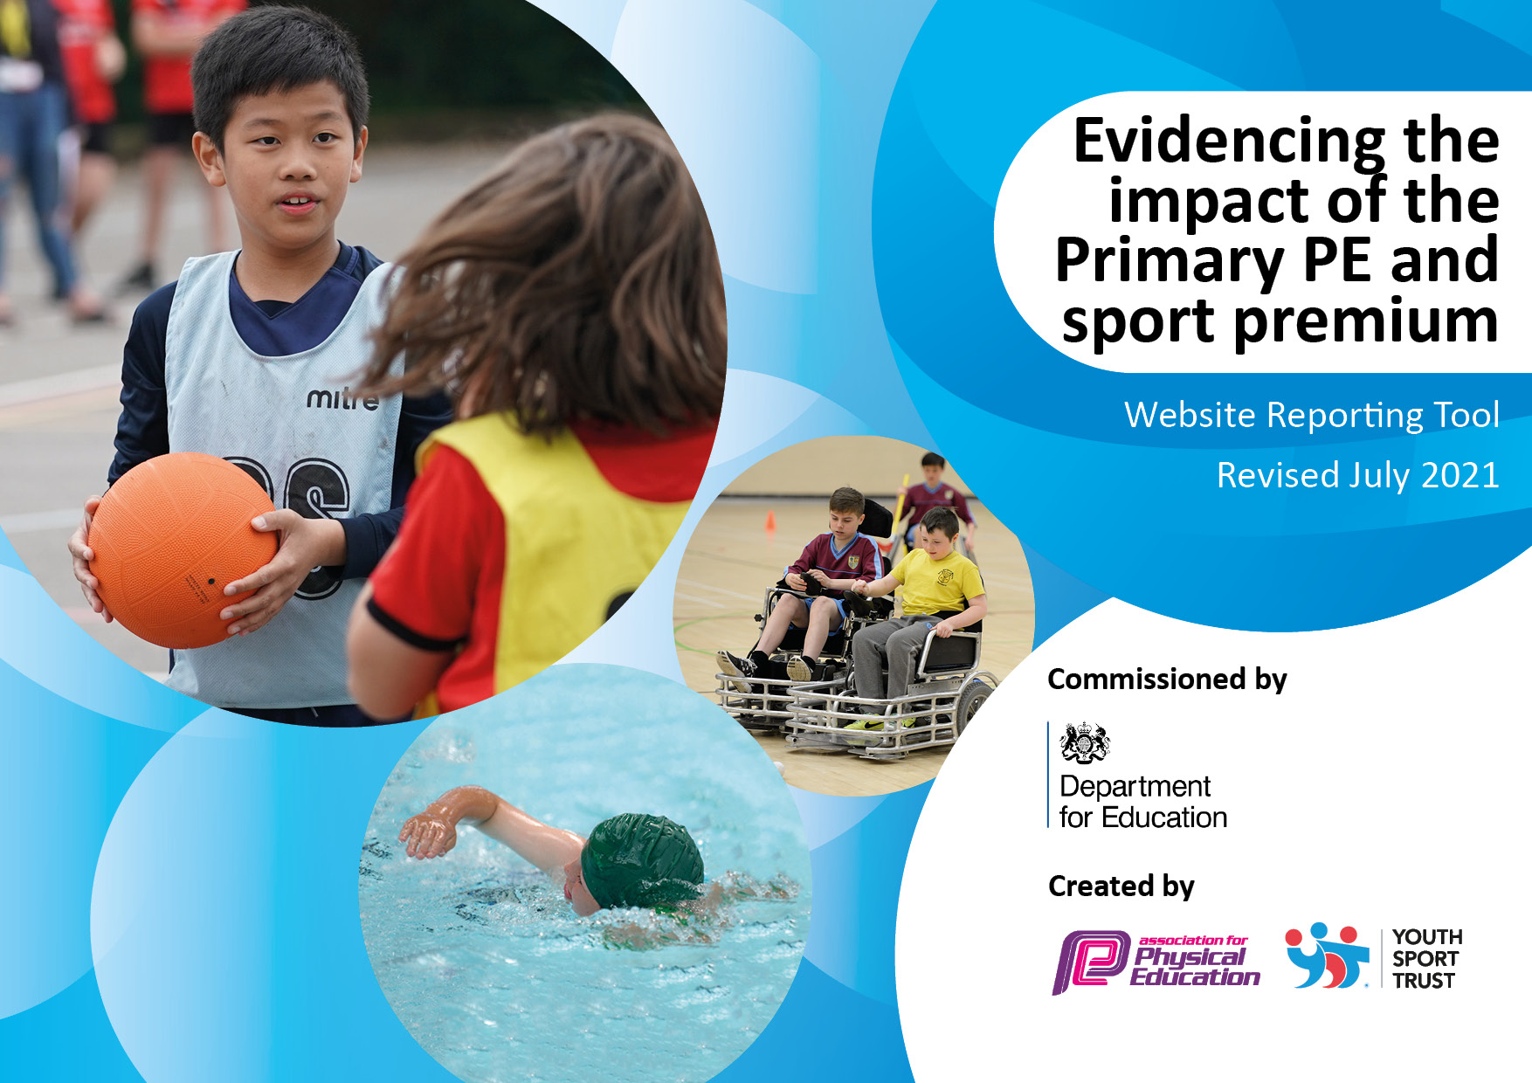
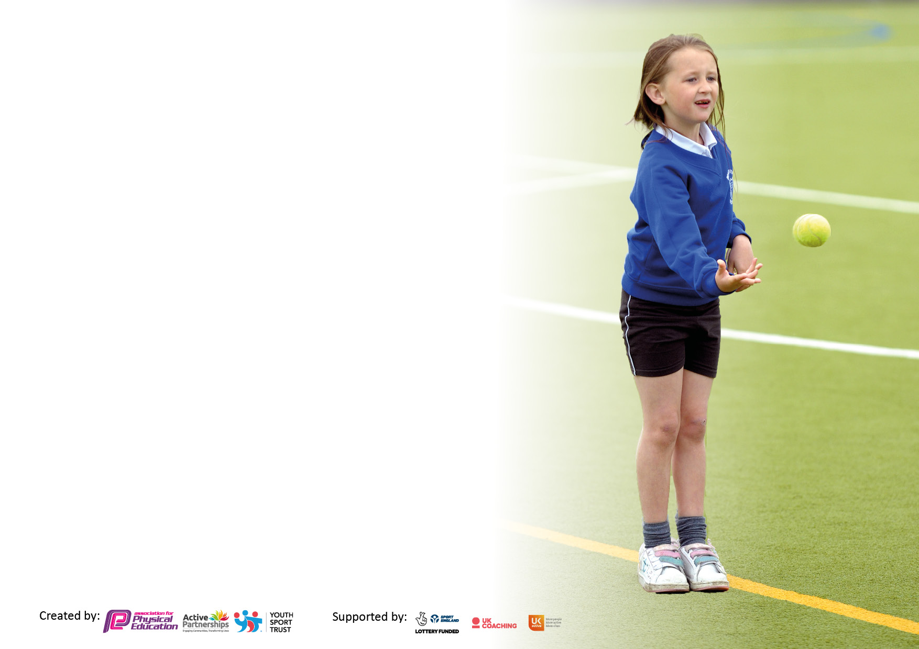

It is important that your grant is used effectively and based on school need. The Education Inspection Framework makes clear there will be a focus on ‘whether leaders and those responsible for governors all understand their respective roles and perform these in a way that enhances the effectiveness of the school’.

Under the Quality of Education Ofsted inspectors consider:
Intent - Curriculum design, coverage and appropriateness
Implementation - Curriculum delivery, Teaching (pedagogy) and Assessment
Impact - Attainment and progress

To assist schools with common transferable language this template has been developed to utilise the same three headings which should make your plans easily transferable between working documents.

Schools must use the funding to make additional and sustainable improvements to the quality of Physical Education, School Sport and Physical Activity (PESSPA) they offer. This means that you should use the Primary PE and sport premium to:

- Develop or add to the PESSPA activities that your school already offer
- Build capacity and capability within the school to ensure that improvements made now will benefit pupils joining the school in future years
- The Primary PE and sport premium should not be used to fund capital spend projects; the school’s budget should fund these.

Pleasevisitgov.ukfortherevisedDfEguidanceincludingthe5keyindicatorsacrosswhichschoolsshoulddemonstrate animprovement.Thisdocumentwillhelpyoutoreviewyourprovisionandtoreportyourspend.DfEencouragesschools to use this template as an effective way of meeting the reporting requirements of the Primary PE and sport premium.

We recommend you start by reflecting on the impact of current provision and reviewing the previous spend.

Schools are required to publish details of how they spend this funding, including any under-spend from 2019/2020, as well as on the impact it has on pupils’ PE and sport participation and attainment. All funding must be spent by 31st July 2022.

We recommend regularly updating the table and publishing it on your website throughout the year. This evidences your ongoing self-evaluation of how you are using the funding to secure maximum, sustainable impact. Final copy must be posted on your website by the end of the academic year and no later than the 31st July 2021. To see an example of how to complete the table please click HERE.
Created by: Supported by:

Details with regard to funding
Please complete the table below.

Total amount carried over from 2019/20 | £1600
Total amount allocated for 2020/21 | £10,400
How much (if any) do you intend to carry over from this total fund into 2021/22? | £10,400
Total amount allocated for 2021/22 | £10,400
Total amount of funding for 2021/22. To be spent and reported on by 31st July 2022. | £20,800
Swimming Data
Please report on your Swimming Data below.

Meeting national curriculum requirements for swimming and water safety.  N.B. Complete this section to your best ability. For example you might have practised safe self-rescue techniques on dry land which you can then transfer to the pool when school swimming restarts.  Due to exceptional circumstances priority should be given to ensuring that pupils can perform safe self rescue even if they do not fully meet the first two requirements of the NC programme of study | Due to COVID 19 and availability of local swimming pools during the summer term, swimming lessons did not take place this year.
What percentage of your current Year 6 cohort swim competently, confidently and proficiently over a distance of at least 25 metres?  N.B. Even though your pupils may swim in another year please report on their attainment on leaving primary school at the end of the summer term 2020.  Please see note above | 81%
What percentage of your current Year 6 cohort use a range of strokes effectively [for example, front crawl, backstroke and breaststroke]?  Please see note above | 81%
What percentage of your current Year 6 cohort perform safe self-rescue in different water-based situations? | 100%
Schools can choose to use the Primary PE and sport premium to provide additional provision for swimming but this must be for activity over and above the national curriculum requirements. Have you used it in this way? | Yes/No

Action Plan and Budget Tracking
Capture your intended annual spend against the 5 key indicators. Clarify the success criteria and evidence of impact that you intend to measure to evaluate for pupils today and for the future.

Academic Year: 2020/21 | Total fund allocated: | Date Updated:
Key indicator 1: The engagement of all pupils in regular physical activity – Chief Medical Officers guidelines recommend that primary school pupils undertake at least 30 minutes of physical activity a day in school |  |  |  | Percentage of total allocation:
 |  |  |  | 27%
Intent | Implementation |  | Impact
To access Halton School Games Festivals which are  designed as an introduction to sport,  physical activity and healthy active  lifestyles. These fun events are targeted at specific groups with some festivals having a focus on inactive pupils  Access Halton School Games support to develop an action to ensure we continue to meet the governments requirement that all primary children undertake at least 30 minutes of physical activity a day in school. | Purchase of Halton School Games – Enhanced Package and all information shared with staff via dedicated PE Resource folder on the staff share. | £495.00 | 60 Ks2 children have represented the school in competitive fixtures in the school year. | How to increase children participation in ks1.  What festivals do the children want to participate in next ear?
To make break times more active for children by resurfacing the playground. | PE Co-ordinator to work with the sports crew to design a new playground. | £4308.00 | 100 % of children questioned on pupil voice have enjoyed the new playground markings.  88% stated the running race track was their favourite. | Caretaker to pressure wash the playground each term.
Ensure learning behaviours are  appropriate during lunchtimes. | Purchase playground shed with age appropriate equipment for children to use including footballs, dancing equipment, skipping ropes, tennis equipment etc. | £1000 | 92% of children have stated that they have enjoyed the new equipment available on selected days. Children have expressed that they have also enjoyed utilising the field as much as possible in the spring/summer term. | PS to work with MDA and liaise which equipment is working and has a box of additional resources which will be distributed throughout the year.
Key indicator 2: The profile of PESSPA being raised across the school as a tool for whole school improvement |  |  |  | Percentage of total allocation:
 |  |  |  | 9.5%
Intent | Implementation |  | Impact
Dedicated ‘Sports Page’ on the school website and a sports notice/ display board in school highlighting sporting achievements and updates. | PE Co-ordinator to have allocated time to update and review. | £165 | Children are proud to be pictured on sports display, school letter and in golden tie assembly. | To continue next year.
To develop cross-curricular links with Literacy to buy ‘sport specific’ reading text books for KS2 children to read during free time in school. | PE Co-ordinator to comply pupil voice to gain insight on books, sports and sports stars that the children will enjoy reading about. | £182.16 | 88% of boys questioned have enjoyed reading sport specific books. | Review books on offer and any new books available to update the library.
Purchase sport kits (with school logo) to be used by teams representing the school in competitions. | Get children for homework/early morning work activity to design a sports kit. | £959 | Children feel more sense of pride when going to sporting fixtures. | To make sure kit is washed after each sporting fixture.
More classes to go swimming (Year 4,5,6) for a whole term.  Top up funding for swimming. | Staff will use swimming lessons as a CPD opportunity. | £1200 | KS2 staff will have the knowledge of expectations for end of KS2. They will feel confident when discussing water safety back in the class room too. At least 90% of pupils will be able to swim 25m, 70% will be able to swim a range of strokes and 100% will meet the requirements for performing safe rescue. | To continue next year.

Key indicator 3: Increased confidence, knowledge and skills of all staff in teaching PE and sport |  |  |  | Percentage of total allocation:
 |  |  |  | 3.75%
Intent | Implementation |  | Impact
and be able to do and about | intentions: |  | can they now do? What has
what they need to learn and to |  |  | changed?:
consolidate through practice:
Staff from Year 2 up to Year 6 to participate in Cricket sessions led by a qualified cricket coach to develop CPD. | Staff will use cricket lessons as a CPD opportunity. | £200  £260  Staffing Costs:  £500 | Pupils to receive high quality cricket coaching from fully qualified coaches and staff to receive CPD training. | To conduct staff voice and pupil voice to see what different sports to offer.
PE co-ordinator and Geography co-ordinator to attend orienteering CPD opportunity. | Staff will use orienteering course as a CPD opportunity. | £100 | Staff to receive training and to then discuss next steps. | Is this as a school that we invest in for the next year.
Key indicator 4: Broader experience of a range of sports and activities offered to all pupils |  |  |  | Percentage of total allocation:
 |  |  |  | 6.9%
Intent | Implementation |  | Impact
To have fully stocked and resourced PE equipment to enable all children to access required resources during PE lessons. | To purchase new and replenish resources used for teaching all children. | £1225.20 | To improve the sports provision so that pupils can practise their skills. | Continue in 2022-2023.
To purchase balance and play equipment for EYFS area to meet early learning goals. | To purchase new and replenish resources used for teaching all children. | £211.57 | To improve the sports provision so children can meet early learning targets. | Continue in 2022-2023 and review with EYFS teacher.

Key indicator 5: Increased participation in competitive sport |  |  |  | Percentage of total allocation:
 |  |  |  | 6.6%
Intent | Implementation |  | Impact
Provide opportunities for pupils across the school to represent Pewithall in competitions and festivals. | Raising the profile of PE in school during achievement assemblies and in school newsletters. | £495 | More children have attended these events, increasing their confidence and experience of competitions against other schools. | This will again be a focus for 2022-2023. Girls’ opportunities continue to be a focus.
Inter school sports competitions, for all levels of ability. | Upgraded equipment to offer a range of inter school sports competitions such as archery, mini golf and kurling. | £766.06 | More children have attend these events, increasing their confidence and experience of competitions against other classes and set their own personal goals/targets to beat. | To carry on next year and have a range of different sporting competition.
Development of sports day to include more competitive elements within key stages and a range of different stations. | Sports day competitive activities to provide greater inter-class competition through the use of upgraded equipment. | £124 | This year has been the first sports day that we have opened for parents/careers to attend for 2 years. | Review did the children enjoy the range of activities on offer. Year 6 children to continue to take on leadership roles.
