PEWITHALL PRIMARY SCHOOL

REMOTE LEARNING POLICY
Please note that this school is committed to safeguarding and promoting the welfare of children and young people and expects all staff and volunteers to share this commitment.

At Pewithall School we believe the overarching aim of our remote provision is to “Keep connected”. It is important that all children maintain a relationship with their class teacher, their peer group, and the school family. It is also vitally important that all children feel supported both academically and emotionally during periods of lockdown.

The remote education at Pewithall is as close to the classroom curriculum as possible. And, just like our classroom curriculum, it is carefully sequenced and ensures that children obtain the building blocks they need to move on to the next step.

The ‘remote curriculum’ is the broad term encompassing any learning that happens outside of the classroom, with no teacher present in the same location as the child. The way in which our remote curriculum is delivered varies slightly depending on what content is being delivered, and the age and stage of the children. In every class all children will access the same learning objectives as their peers, whether they are home learners or learning at school. This approach means that all children are included and their circumstances relating to COVID-19 mean they should never feel like they are missing out.

For online delivery we use: Tapestry, Microsoft Teams and our school website class pages. This allows us to share a range of tailored resources that include pre-recorded videos as well as links to online resources that support children’s learning at home. Home learning packs are delivered and collected weekly to the doors of most of our Home Learners. Online resources supplement our home learning packs. Teachers use Tapestry and Teams to give home learners instant feedback, support if they need it and as means to motivate the class.

When school sustains high levels of staff absence owing to the pandemic, we will always endeavour to maintain this our remote learning offer where possible. We will only deviate from this policy when we have exhausted all our options. As the pandemic evolves, we may modify our provision for remote learning considering teachers’ workload in relation to the number of children being taught in school and remotely.

In the event of a class closures, we will review the circumstances and at the very least direct parents as to how they can support their child’s home learning; providing the teacher is well and isolating at home, he or she will continue to provide and monitor home learning.

INTENT

1. At Pewithall School we will make best endeavours to use remote education to provide and teach a planned and well-sequenced curriculum to those pupils who need to be educated at home.
2. We will ensure that the DfE guidance for safe remote learning and safeguarding underpin this policy.
3. The teaching provided through remote learning will ensure that knowledge, skills and understanding are built incrementally so that pupils can make good progress through the school’s curriculum.
4. Pewithall School with the help of our school community will do all that it can within its resources to overcome any barriers to digital access for all pupils.
5. We will provide appropriate resources to structure learning, which will be supplemented with other forms of communication to keep pupils on track and to assess their progress.
6. The school will do its best to put in place systems for checking regularly whether pupils are engaging with their work and making progress. We will offer support and advice where engagement is a concern.
7. Teachers will set meaningful and ambitious work each day in an appropriate range of subjects.
8. Within our resources we will do our best to provide a minimum of 3 hours a day on average across the cohort in KS1, with less for younger children and up to 4 hours a day in Key Stage 2.
9. The school will use its best endeavours to secure the educational provision called for by pupils’ special educational needs and vulnerable pupils.
10. We will publish our ‘Remote Learning Offer’ as an appendix to this policy.

IMPLEMENTATION

1. The senior leadership team will be given overarching responsibility for the quality and delivery of remote education, including that provision meets the DfE expectations for remote education (published Jan 2021)
2. The school will use safe digital platforms (Microsoft Teams, Tapestry, School website) for remote education provision across the school and staff will be trained and confident in its use.
3. Remote learning may include pre-recorded videos and/or resources to support children’s learning to complete either online or home learning packs that are delivered weekly.
4. Remote learning will set expectations that are appropriate to the pupils’ age, stage of development or special educational needs.
5. Remote learning will provide opportunities for interactivity, including questioning and discussion.
6. Pupils will receive timely and frequent feedback on how to progress, using digitally facilitated or whole-class feedback where appropriate or via weekly telephone calls made by class teachers. All returned work will be marked and stuck into schoolbooks.
7. The school will work collaboratively with families, putting in place reasonable adjustments as necessary, so that pupils with SEND can successfully access remote education alongside their peers.
8. Where individuals who are self-isolating are within the DfE definition of vulnerable, the school will use its reasonable best endeavours to put systems in place to keep in contact with these children.
9. When a vulnerable child is asked to self-isolate, the school will notify their social worker (if they have one) and school leaders will agree with the social worker, reasonable and practical ways to maintain contact and offer support to the vulnerable child.
10. The school will put in place reasonable, practical procedures to regularly check if a vulnerable child is able to access remote education support and to support them to access it as far as possible.

IMPACT

Remote teaching will ensure that knowledge, skills and understanding are taught incrementally so that pupils can make good progress through the school’s curriculum. In addition, it will provide the opportunity to monitor the well-being of our pupils. The senior leadership team and governors will keep the policy and provision for Remote Education under regular review as we are aware it will continue to evolve over time. The views of stakeholders will be considered as we review our offer.

Please note:
This policy needs to be read in conjunction with our Safeguarding and Child Protection Policy as well as our E-Safety and Acceptable Use Policy.

Appendix 1
Pewithall Primary School
Remote Education Provision: Information for Parents and Carers

This information is intended to provide clarity and transparency to pupils and parents or carers about what to expect from remote education where national or local restrictions require entire cohorts (or bubbles) to remain at home. As a school we need to make arrangements to continue the education of your child should there need to be any closures in school due to COVID-19.

The remote education at Pewithall is as close to the classroom curriculum as possible. And, just like our classroom curriculum, it is carefully sequenced and ensures that children obtain the building blocks they need to move on to the next step.

The Remote Curriculum- The ‘remote curriculum’ is the broad term encompassing any learning that happens outside of the classroom, with the teacher not present in the same location as the children. The way in which our remote curriculum is delivered depends upon what content is being delivered and the age and stage of the children:

Online learning where the curriculum is delivered via technology such as Tapestry, Microsoft Teams and the school website. This may include
pre-recorded videos and/or resources to support children’s learning to complete either online or in a paper-based exercise book at home.
Sign posting families to external apps and websites that would further support engagement in remote learning.

Links will be provided in this timetable to where parents and children can find the online teaching videos and resources for each lesson. The expectations of lessons each day will be:
• A maths lesson
• An English lesson
• A phonics/Grammar/Reading activity (Foundation Stage and KS1)
• Spellings/Grammar/reading activity (KS2)
• A lesson for one of the foundation subjects (science, history, geography,
music, computing, art, French RE,PE)
• Daily assemblies pre-recorded and uploaded on Teams
• Reminders to Log on to Times Tables Rock Stars and Sum Dog (If you
are having difficulties logging in please contact school for details)
• The timetable will be shared with all parents and carers as well as a
‘remote learning pack’ which will consist of learning activities, a
reading book and any resources that might be required for example
white boards, pens, counters etc.

How your child will be taught remotely
• There will be daily contact with pupils via Tapestry or Teams.
• Learning to be shared on Tapestry, Teams and or the website.
• Printed work packs will be delivered by a member of the school team.
• Work packs will include time tables for the children to follow.
• Learning objectives are clearly outlined.
• Letters and information are provided for children and parents as a
guide of what is expected and how to teach that lesson. In this way
we will show our parents and carers how best to teach that lesson.
• Completed work will be collected on your delivery slot.
• Returned work will be marked, assessed and stuck into children’s books.
• A weekly phone call with parents to check in and to give feedback to
children at home.

It is important the children engage with the remote learning activities to continue their education during periods of self-isolation however we do acknowledge that each family’s home circumstances are unique and there may be factors that affect engagement with home learning. These may include parents working from home or limited access to technology among other factors. Communication is essential and we ask that if parents are finding things difficult to get in touch with their child’s class teacher so we can support and put measures in place.

If a child is not engaging in remote learning the class teacher will contact parents to offer support and put measures in place to help to engage them with their learning. We will work together.

Access to Technology at Home.
We understand and appreciate the challenges that families may face when accessing elements of our remote learning online. We will contact families and ask directly if they need support with technology at home. We have been fortunate to provide over 20 families with laptops and devices to support their remote education. If parents are experiencing difficulties with a lack of technology in the home or sharing of devices again we please ask that you contact school and we can put support in place.

Online Learning Resources:
Times Table Rockstars – All children from Year 2 to Year 6 have a logon for Times Tables Rockstars. This is a fantastic website that supports children in learning their times tables.

Appendix 2
EYFS Timetables

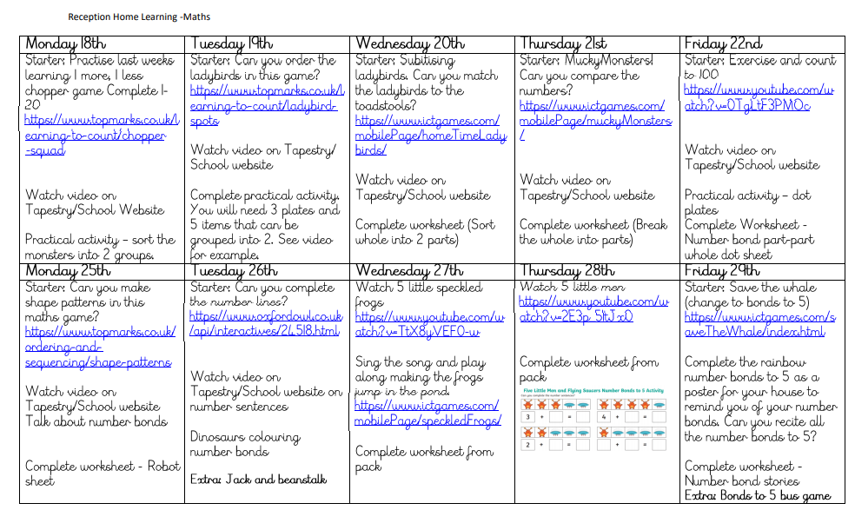

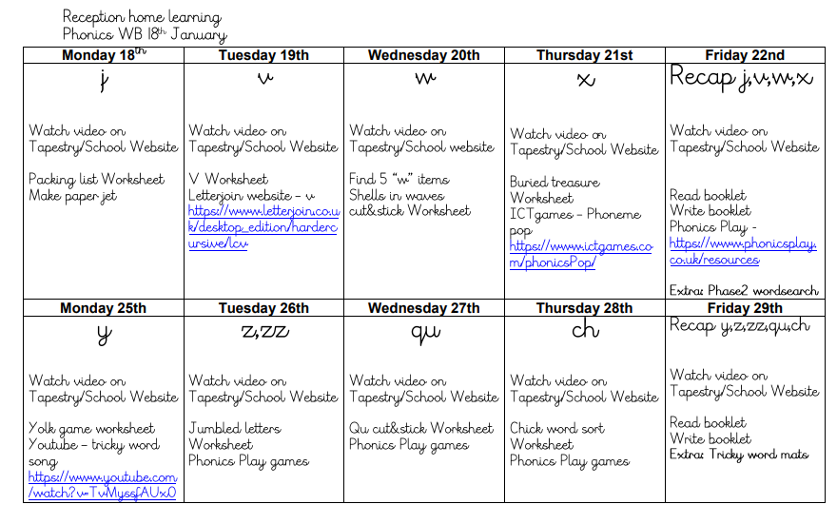
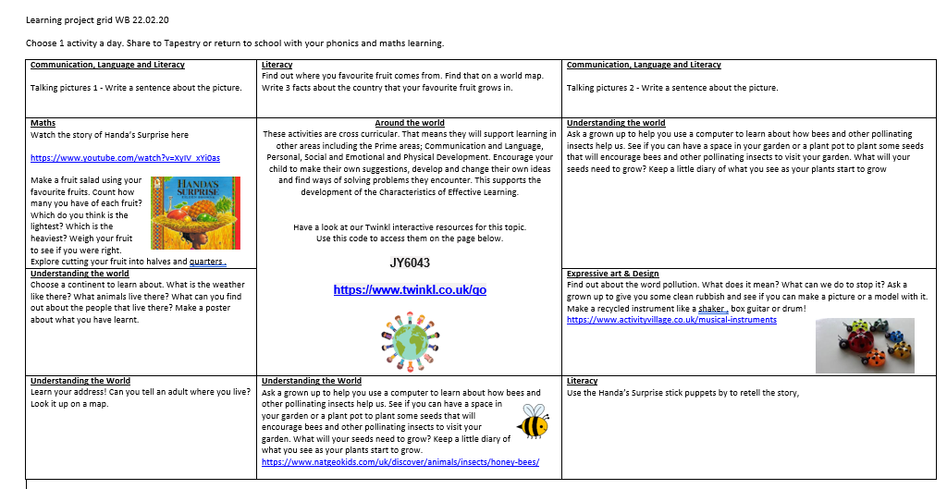

Appendix 3 KS2 Timetable

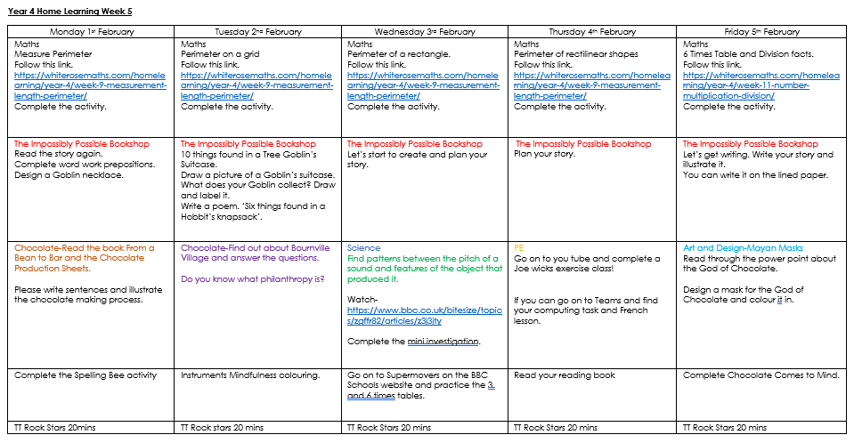

Policy reviewed: May 2022
Policy minuted: June 2022
Date to be reviewed: June 2024
Signed: 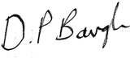 Headteacher
Date:
Signed: 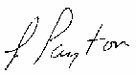 Chair of Governors
Date:

