Food Chain Vocabulary

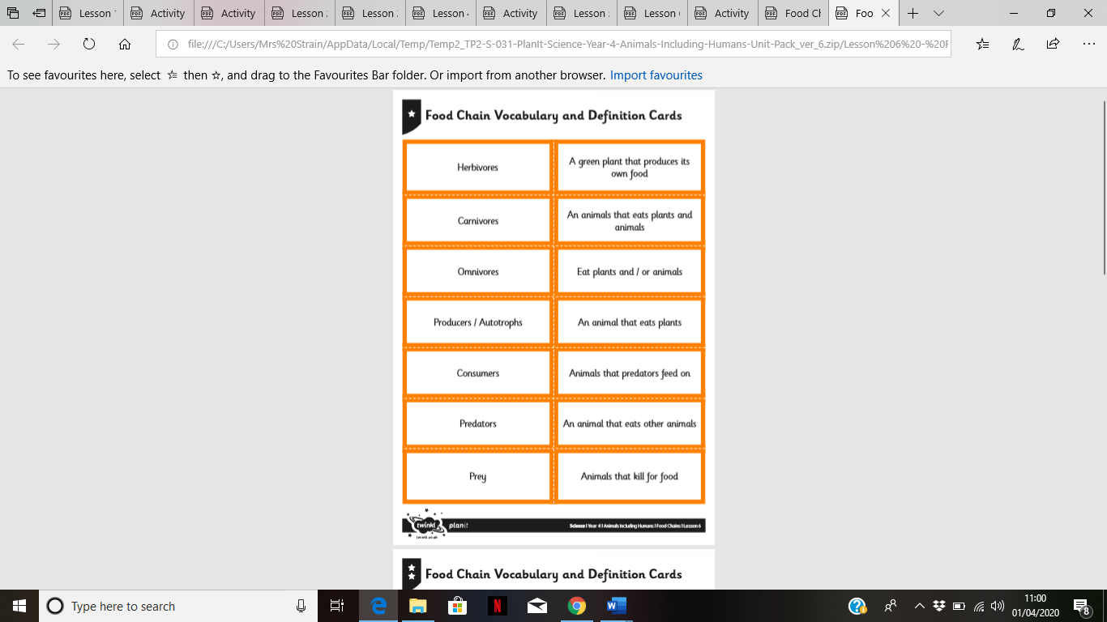

Use a dictionary or the internet to find out the definitions.

Draw a picture for each.