Friday 15th May 2020
Good afternoon Year 2 and to all your families too,
Hope you’ve all had another good week, thank you again for working so hard.
It’s a long time since we were all together in our class. Just before we closed our school we were planning to walk on the towpath alongside the Bridgewater Canal. Remember we had been learning about canals and James Brindley? I wondered if you might like to walk along the towpath for your daily exercise. You will be walking on the same path that the horses walked on while they pulled the narrowboats. Please make sure you go with a grown up. At the bottom of this letter I have put some photographs of things you might spot along the way. Look at the wall, can you see where as the horses pulled the boats the rope rubbed against the soft sandstone and after a while wore it away? On your walk see if you can see where the boats were tied up.
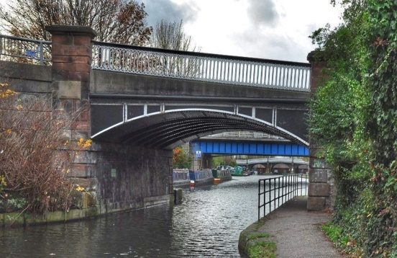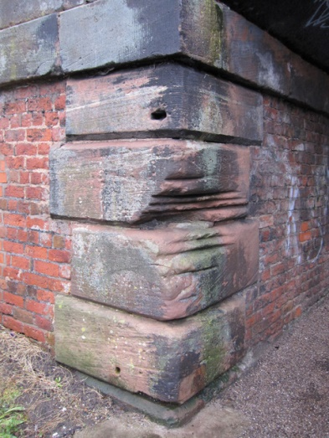
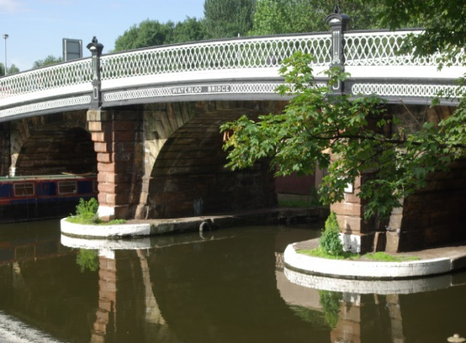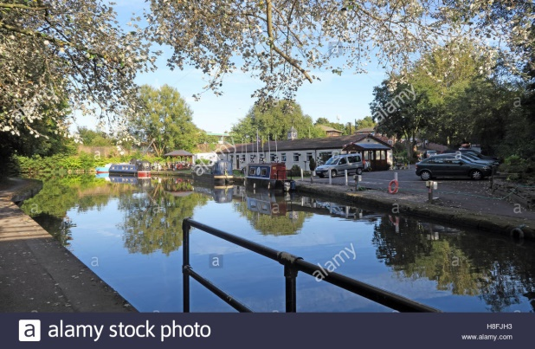
Hope you have a lovely weekend and a good week
Keep yourselves safe and well. Sending a big hug to you all from Mrs. Hancock xxxxx

